Date: 2016.10.14

# Requirement:

1: Update of outbound report able to auto calculate the total cycle time?

PF: Total cycle time is refer to which time frame:  from  ?? to ?? time? Format in hour?

Replied: Start time from picking to FG update timing in hour, customer give us a target of 2.5hr.

Revised Change requests:

[25 Oct] Marcus:

TAT = from Pick time to FG Time.

Replied:

Able to change the timing after 1745 the cycle time stop and continue resuming the next day at 8am, as for weekend cycle time start on incoming Monday 8am.

Meet TAT (<= 2.5)      =  # of SO meet KPI

Replied: Our KPI change to <=2.0

Not meet TAT( > 2.5 )= # of SO not meet KPI

Replied: Our KPI change to >=2.0

Customer advise 4pm order will flow over to the next day to continue, therefore SKH staff will stop all activities at 1745

# System Changes:

Date: 2016.10.14

Add TAT (Pick Time to FG Time) column after FG Time.

If > ~~2.5~~ 2.0 hr highlight red for column TAT

## COdelkup:

Maintain outbound TAT in Codelkup .

Select * from codelkup where listname = 'OFITAT'

Select TAT = Short, * from CODELKUP where listname = 'OFITAT'

and code = 'OUTBOUND'



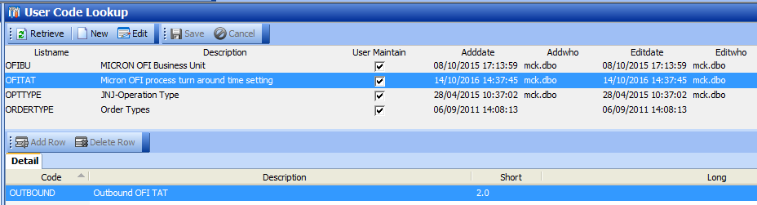

## Holidays maintenance

New Table: SCH_OFI_Holidays

To maintain public holidays for KPI Calculation.

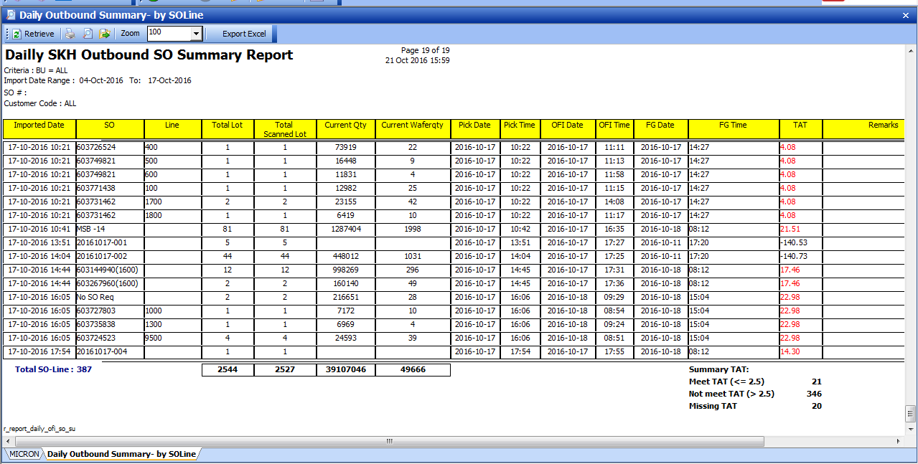

Summary TAT:

Meet TAT (<= 2.0) = # of SO meet KPI

Not meet TAT( > 2.0 )= # of SO not meet KPI

Missing TAT = # of order missing FG time

Milestone:

Pick Time = Picklist generated time from WMS

OFI Time = Scan OFI Completed time

FG Date/time = Goods ship time (manual updated by user)

[Revised: 25/10/2016]

Over all TAT calculation:

Pick Time = if Weekday – Pick Time after 1745, get start time as next day 0800 HRS,

If Friday – Pick time after 1745, get start time as next Monday 0800 HRS

** On week day the timing after 1745, the cycle time stop and continue resuming the next day at 8am

Weekend order will start on next Monday 0800 hr.

As for weekend SKH will not be able to ship out only until incoming Monday.

TAT = Pick Time – FG Time – (weekend – Public Holiday )

Updated [2016.11.21]

Holiday master:

Master - > Maintain Holidays

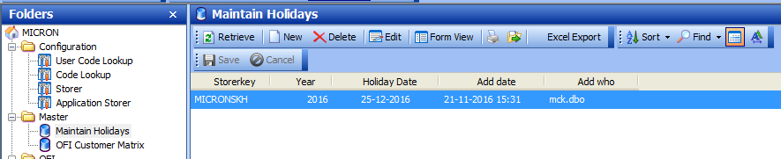

Updated report:

